Chilkat Indian Village
Housing Improvement Program
HC 60 Box 2207
haines, Alaska, 99827
(907) 767-5505 FAX (907) 767-5518
Accepting Applications
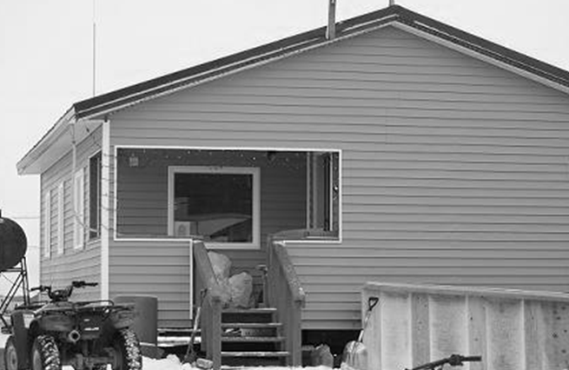
The Housing Improvement Program (HIP-BIA) is a Grant Program to help eligible Indians & Alaska Natives Repair/Renovate existing housing and in some special cases, build New Homes. The program is for those who are unable to obtain housing assistance from other sources.
TO APPLY, PICK UP AN APPLICATION AT YOUR TRIBAL COUNCIL OFFICE.
Application Requirements:
Your application will be incomplete without the following information below.
- Provide a copy of your Tribal Enrollment Card & DOB
- Proof of Income for All Household Income & a signed 1040 Form.
- Proof of ownership or obtain 25 yr. lease agreement
- If you or a family member are claiming disability, you must provide a letter stating disability from a Doctor.
The Tribal Housing Office does not make the final decision on who gets a Grant. They send their HIP Applicant List/ Eligibility Status/ Priority Ranking by Points to, Alaska Regional Housing Office for review of Points and Data from ALL VILLAGES in Alaska.

*****THE DEADLINE FOR ALL APPLICATIONS TO BE TURNED IN IS (JANUARY 15, 2014)*****

