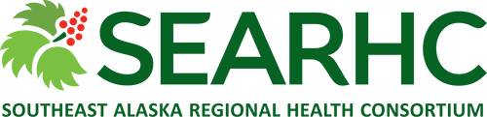
PATIENT ACCESS REPRESENTATIVE
This position functions within the health information department to conduct daily reception, medical records, and billing duties which directly support staff and patients/clients of SEARHC.
Requirements: HS Diploma or GED and two (2) years’ general office experience, medical office experience is a plus! This position is Intermittent and is located in Haines Health Center and offers a beginning hourly wage of $15.24+ DOE.
Be a part of the SEARHC team and take pride with us in our vision to “Improve the health status of Native People in Southeast Alaska and other partners to the highest possible level.”
To inquire further contact Ella Nierra, Recruiter at 907.364.4596 or recruitment@searhc.org Visit our website www.searhc.org APPLY TODAY!

